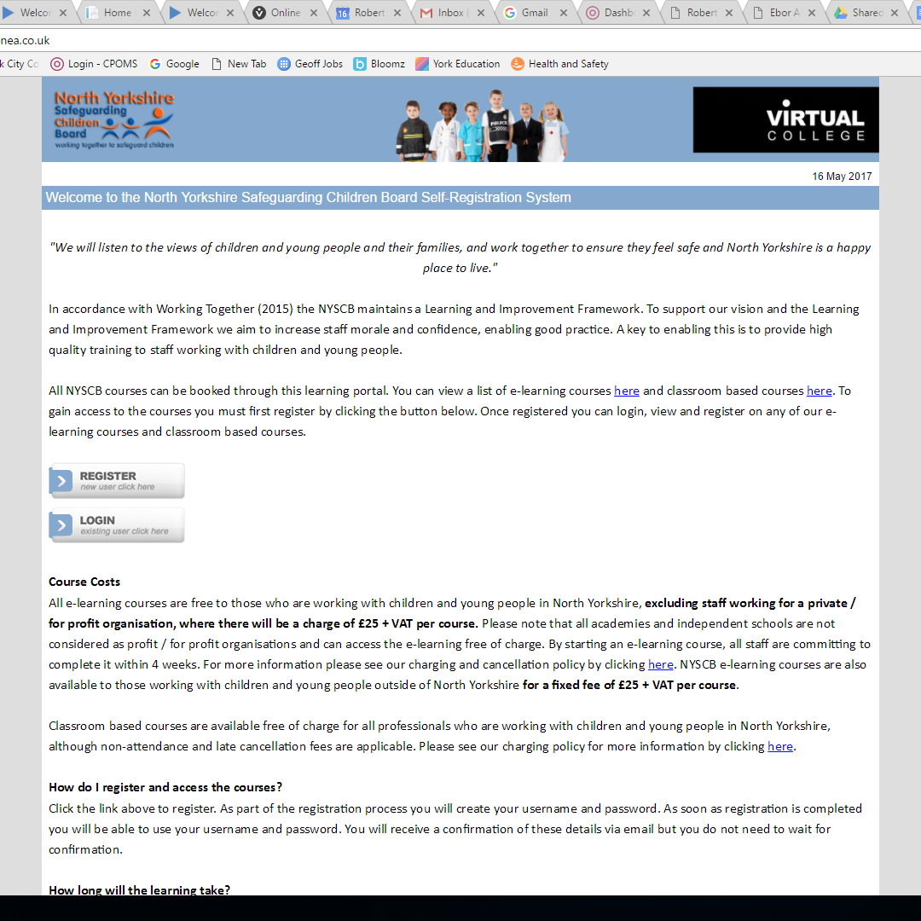

Click here to register

Choose SCHOOLS then
NON_NORTHYORKSHIRE PRIMARY SCHOOL

Then click here to REGISTER

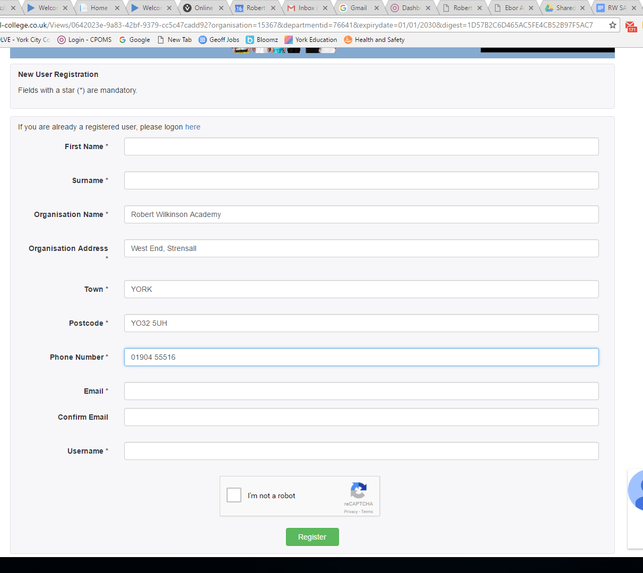

Fill in your First & Surname

Then fill in the school details:
Robert Wilkinson
West End, Strensall
York
YO32 5UH
Tel. 01904 555160

Fill in your email address

Choose a Username (You can use your email address)

Click the box to say you are not a robot!

