Do you have a Child Protection Concern?
If so:-
- Speak with Miss McGuinn (Designated Safeguarding Lead) as soon as possible.

- If unavailable, speak with Mrs Wilson (Deputy Designated Safeguarding Lead).

- It is essential that you report your concerns verbally at the absolute earliest opportunity.
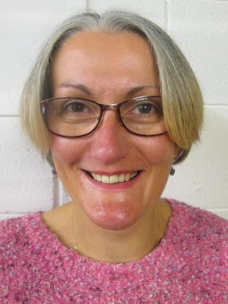
Designated Safeguarding Leads
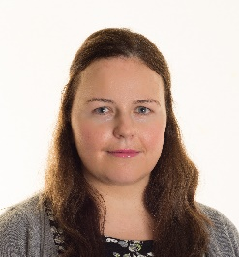
Rebecca McGuinn (DSL) Jo Wilson (DDSL)
 | 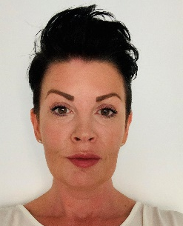 | 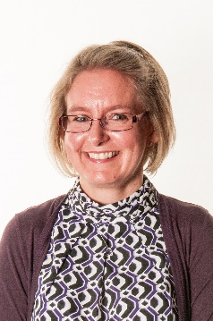
Mr Evans  Head Teacher | Mrs Sutton  Deputy Head | Mrs Smith  Business Manager
In the event of the DSL or DDL being unavailable please contact a member of the safeguarding support team below

