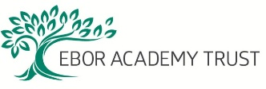

Do you have a Child Protection Concern?
If so:-

- Speak with Jo Sutton (Designated Safeguarding Lead) as soon as possible.

- If unavailable, speak with Chris Evans (Deputy Designated Safeguarding Lead).

- It is essential that you report your concerns verbally at the absolute earliest opportunity.

Designated Safeguarding Leads
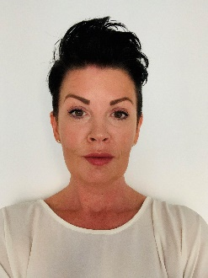

Jo Sutton
DSL
Chris Evans
Deputy DSL Deputy DSL
In the event of the DDSL being unavailable please contact a member of the safeguarding support team below
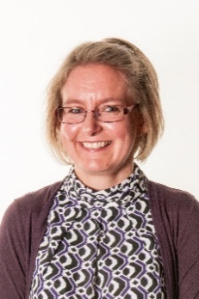
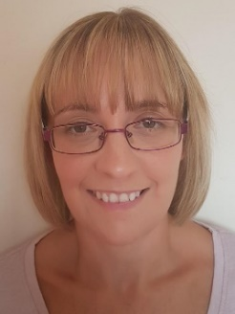

Helen Smith
Business Manager
Kerri Machin
WAC Manager

