Do you have a Child Protection Concern?
If so:-

- Speak with Jo Sutton (Designated Safeguarding Lead) as soon as possible.

- If unavailable, speak with Chris Evans (Deputy Designated Safeguarding Lead).

- It is essential that you report your concerns verbally at the absolute earliest opportunity.
Designated Safeguarding Leads
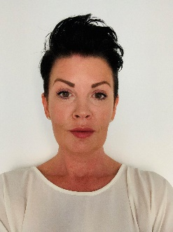

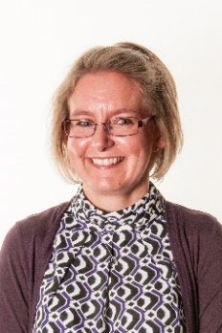
Jo Sutton
DSL
Helen Smith
Business Manager
In the event of the DDSL being unavailable please contact:
Chris Evans
Deputy DSL Deputy DSL

