Do you have a Child Protection Concern?
If so:-

- Speak with Jo Evans (Designated Safeguarding Lead) as soon as possible.

- If unavailable, speak with Anthony David or Donna Bedford (DDSL) or at WAC speak to Vikki Watson or Katie Tymon

- It is essential that you report your concerns verbally at the absolute earliest opportunity.

Designated Safeguarding Leads
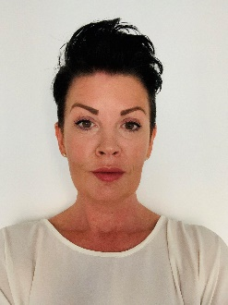
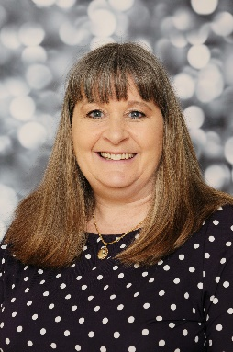

Anthony David
Deputy DSL
Donna Bedford
Deputy DSL Deputy DSL
Jo Evans
DSL
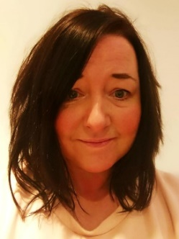
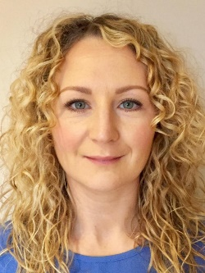
In the event of the DDSL being unavailable please contact a member of the safeguarding support team below
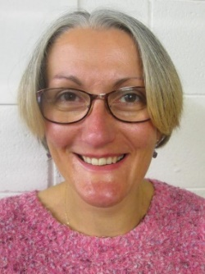

Vikki Watson
Deputy WAC Mgr MgrManager
Katie Tymon
Deputy WAC Mgr
Jo Wilson
DDSL

