Do you have a Child Protection Concern?
If so:-

- Speak with Jo Evans (Designated Safeguarding Lead) as soon as possible.

- If unavailable, speak with Jo Wilson or Anthony David or Donna Bedford (Deputy Designated Safeguarding Leads).

- It is essential that you report your concerns verbally at the absolute earliest opportunity.
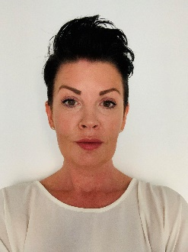
Designated Safeguarding Leads
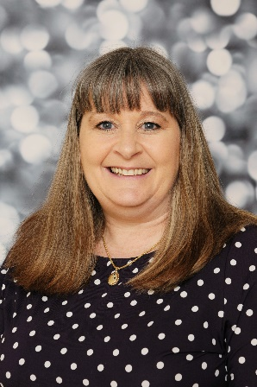
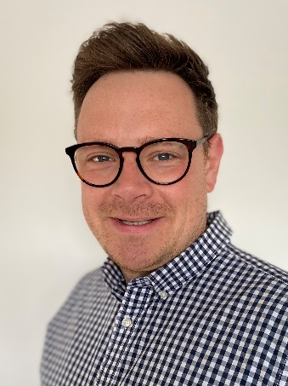

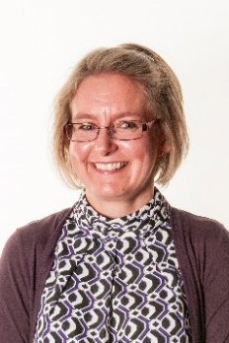
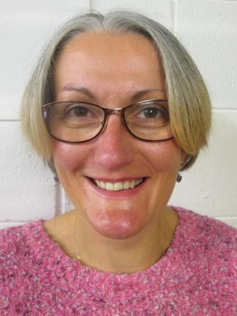
In the event of a DDSL being unavailable please contact:
Jo Wilson
DDSL
Helen Smith
Business Manager
Anthony David
Deputy DSL Deputy DSL
Jo Evans
DSL
Donna Bedford
Deputy DSL Deputy DSL

