Do you have a Child Protection Concern?
If so:-

- Speak with Anthony David or Jo Mould (Designated Safeguarding Leads) as soon as possible.

- If unavailable, speak with Donna Bedford or Jo Wilson (DDSL) or at WAC speak to Vikki Watson or Katie Tymon

- It is essential that you report your concerns verbally at the absolute earliest opportunity.

Designated Safeguarding Leads
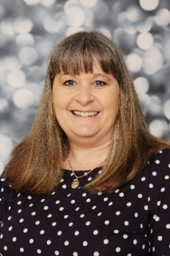
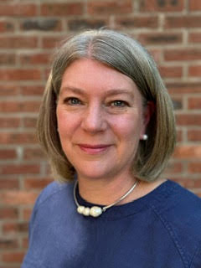

Jo Mould
DSL
Donna Bedford
Deputy DSL Deputy DSL
Anthony David
DSL
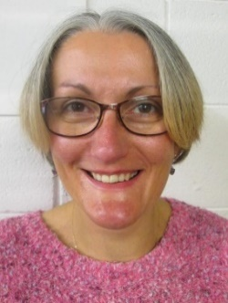
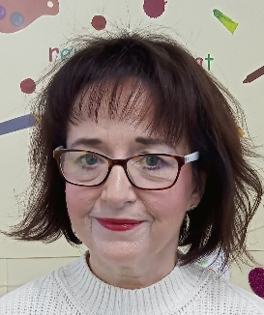
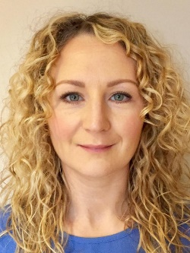
In the event of the DDSL being unavailable please contact a member of the safeguarding support team below

Jo Wilson
DDSL
Vikki Watson
Deputy WAC Mgr MgrManager
Katie Tymon
Deputy WAC Mgr

